

*Artificial Intelligence and Data Engineering*

*Industrial* *Applications*

***Car Suggestion***

________________________________________________________________________

Project report

Luca Caprioli

Martina Marino

Roberta Matrella

Academic Year 2022/2023

Sommario

Introduction 1

Levels of Automation 2

Goal of the project 2

State of the Art 3

Car Buying Apps 3

User Needs 4

Challenges 5

Market Analysis 7

Functional and Non-Functional Requirements 8

Functional requirements 8

Non-functional requirements 8

Platform Architecture 9

Working Staff 10

Work Packages 11

Summary Table 11

Work Packages Description 12

WP 1 12

WP 2 12

WP 3 13

WP 3 15

WP 4 16

WP 5 17

GANTT 19

Risk analysis 20

Cloud Risks 20

Hardware Risks 20

Software Risks 21

Artificial Intelligence Risks 21

Privacy Risks 21

# Introduction

Since the first vehicles was invented, some futurists have been dreaming about realizing cars without humans on the driver seat. One of the first demonstrations was a radio-controlled driver-less car built in the 1920's. In the following years also, many movies put the attention on the topic, like *The Love Bug* (*Il Maggiolino Tutto Matto*) following the adventures of the anthropomorphic Volkswagen Beetle named Herbie (1968) or *Supercar,* a TV series in which the protagonist fights the forces of evil together with KITT, an indestructible and fully automated car controlled by an artificial intelligence. In the 1980's, Ernst Dickmanns and his team of Bundeswehr University Munich in Germany managed to alter a Mercedes Benz van to drive autonomously over more than 20 km with top speeds of 96 km/h on an empty highway; by 1989 it was able to recognize obstacles and in the 1990’s it could perform lane changes autonomously. From this demonstration many projects arose with the aim of reproducing this experiment. Since the early 2000’s many universities and car companies have been working on improving vehicle autonomy, but it was always necessary the presence of a human driver to intervene in case of difficult situations.

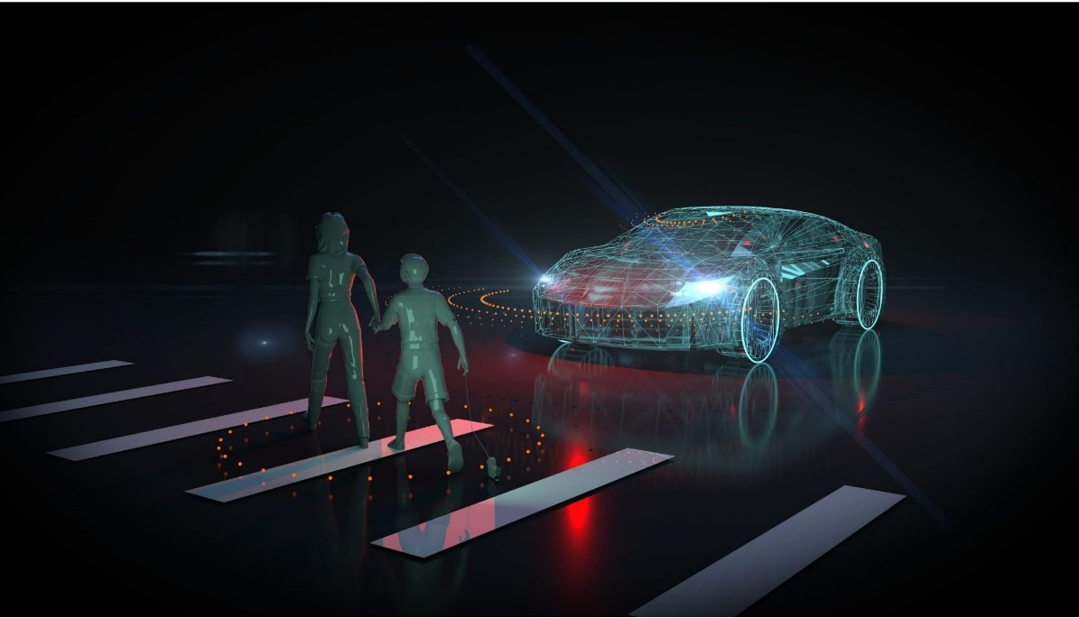Nowadays there is strong competition between newer technology companies (such as Google, Uber and Tesla) and established car companies (such as Mercedes Benz, General Motors, Nissan and many others). Some have been working on autonomous vehicles for years, and there are many working prototypes and trial programs. Some aspects of the driver-less car still need to be refined, and there are many legal, liability, technical and social problems that must be overcome. However, in terms of transport planning into the future, autonomous vehicles should be considered, as they are likely to have significant impacts on travel behaviour and road network operations.

# Mockup of an automous vehicle detection

# Levels of Automation

There are six autonomous driving levels, classified based on their degree of automation. Categorized by the Society of Automotive Engineers (SAE), the spectrum ranges from level 0 to level 5–from no automation to fully autonomous vehicles [1].

At a high level, you can think of the levels of automation as:

* Level 0: No automation at all
* Level 1: Very light automation (cruise control, etc.)
* Level 2: Some automation but always requires human attention
* Level 3: Can self-drive but require intervention in severe conditions
* Level 4: Highly autonomous
* Level 5: Completely autonomous

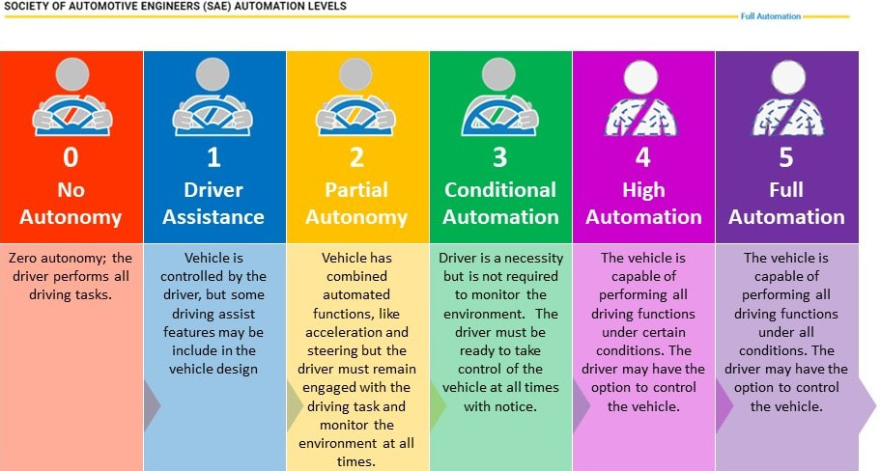

Levels of vehicle automations by SAE

# Goal of the project

The aim of this project is to introduce a product innovation for the vehicles with a level of automation 3 or more with the objective of understanding the “feeling” between driver and car. This is achievable thanks the use of a software for the recognition of the emotions felt by the driver while using the car. Such innovation can be exploited for different purposes, for a car buyer undecided about what car may be the right choice for him/her.

# State of the Art

### Car Buying Apps

Buying a car can be complicated, so over the years many applications have been created to offer features and helpful tools that can simplify the process. The first step is to see what has been done in this field of interest up to know to highlight what has to be maintained and what is matter of innovation.

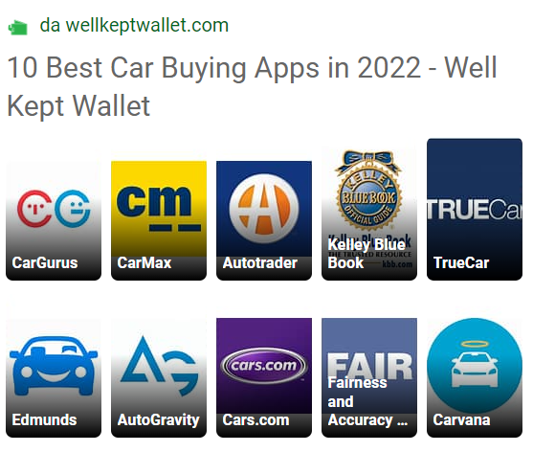With a quick online search of the best car buying apps of 2022 [2], the results are almost always the ones reported below.

Best car buying apps of 2022

Without analysing them one by one we can underline what they have in common. The functionalities offered are the same:

* Used and new cars handled.
* Search filters
* Car comparison
* Drivers and expert’s reviews
* Rating
* Information about dealers
* Search saving
* Leasing

Focusing on the 3 most used of them, they have some more features:

* *CarGurus*: offering details on car history.
* *Carmax*: with free reports and a maintenance service.
* *Edmunds*: exploiting augmented reality and giving a service of market value evaluation.

### User Needs

Buying a car is generally a long-term purchase and one of the most important ones in the life and for this reason there are a lot of factors to consider in choosing the right one. In US, according to data from Statista's Global Consumer Survey [3], at the top of the checklist are fuel efficiency and safety with 56 and 55 percent, respectively. The design is not so taken in consideration and only 32 percent seem to be primarily concerned with the appearance of their new car.

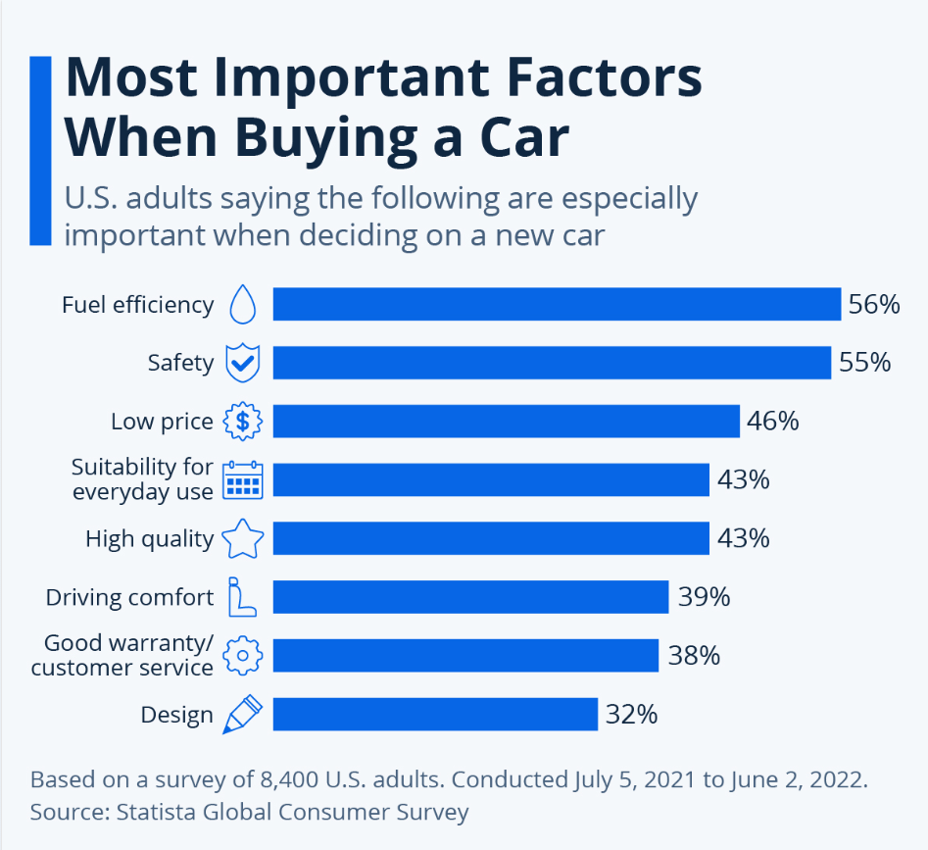

Most important factors in buying a car (US)

Nowadays these are the main factors that people take in consideration for the actual level of automation in which the driver still has a very important role during the trip, but considering a level of automation of 3 or more, the attention is shifted on the interior environment and the passenger experience, because driving is not the primary necessity when using a car. Furthermore

What is missing among the features offered by the apps previously named are the following factors:

* Consideration of emotions: although the main important things to consider when buying a car are technical people in general tend to buy products that they feel could create or already have a connection with.
* Real-time suggestions: for most of the people a car is a big investment, so a ready and precise suggestion specifying every different aspect of the product they are shopping could ease the decision itself.
* Customer history regard: consideration for customers shopping habits, as already used in all the major shopping companies (Amazon, Alibaba and the more niche MAC Cosmetics) could improve the comparison and suggestion quality.
* Interactive experience: an interactive experience is a must for demonstrating to the clients all the possible uses in all the possible situations that could happen with each specific car. It’s like having a fast go through experience of the future uses of the car.

Shortcomings of the different brands regarding costumers interaction

## Challenges

The technologies that cars will adopt will be increasingly pervasive. Cars could become the new smartphone and thus becoming an alternative to them, even replacing them.

The new challenges will be to offer even more accurate and specialized services. People will choose their car not for the performance but for the services it offers. This is why the need arises to think of increasingly complex and technologically enriched platforms on which different types of applications may run.

All this pushes different companies, different from each other, to focus their attention on this market, whose growth in the coming years will be exponential.

Content providers, in-vehicle service providers, data and analytics companies, advertisers, entertainment equipment providers, and social media companies will try to enter in this market making the in-transit experience whatever we want it to be relaxing, productive, or entertaining.

Content creation will likely remain central, and as vehicle interiors adapt to a driverless world, new possibilities will emerge to develop immersive and interactive videos, music, and games. It is increasingly plausible that the entirety of the cabin’s walls and ceiling could become high-definition touchscreens, perhaps incorporating augmented reality technologies. Many of the capabilities in this space already exist but will be vastly expanded to become even more immersive and interactive: high quality content creation, effective content sourcing, targeted advertising, and product placement. New needs will emerge as data and analytics support not only entertainment but a broader set of experiences.

The most successful experience providers will capitalize not only the time spent in the vehicle, but the myriad unique ways customers can consume content. Today’s content and experience leaders may have significant opportunities for growth, as do owners who want to curate branded experiences.

In-vehicle services could also expand, from meals to shopping and beyond. Predictive content analytics will likely be essential to maximizing the in-vehicle experience, collaborating with mobility managers to provide content seamlessly and intuitively to assist passengers with where they are going, how they get there, and what they do along the way. Doing so means tailoring content suggestions based not only on a user’s history—as today’s recommendation systems do—but also with ever-more comprehensive information about the specifics of a trip, entertainment and productivity patterns, and social interactions. Platforms and data will be the lifeblood of this new system.

# Market Analysis

The automotive sector is one of Italy’s major industries and employs 278,000. Last available data (February 2021) showed that in 2020, the automotive sector’s turnover was €106.1 billion, which was 11% of Italy’s manufacturing turnover and 6.2% of Italy’s GDP [4]. The conversion from thermal engines to electromobility (hybrid and electric) is reshaping the sector and may offer opportunities for U.S. vehicle component, charging infrastructure, and diagnostic equipment manufacturers. Major changes in the circulating stock may also drive the development of the aftermarket sector in Italy.

In 2021, 797,243 vehicles (443,819 cars, 290,021 light commercial vehicles, and 63,403 trucks and buses) were produced in Italy, a 2.6% increase over 2020. 1,457,952 new cars, 5.5% more than in the prior year, were registered in 2021. The leading brands were the Stellantis Group (37.82% of the market), followed by the Volkswagen Group (16.52%), and the Renault Group (11.48%). In January 2021, FCA and PSA merged and became Stellantis, the world’s fourth largest automotive group, with 551,421 units registered in Italy in 2021 compared to 537,071 units for FCA and PSA in 2020 (or 38.88% of the market). 80,989 units by Ford Motor Company were registered in 2021 (5.55% of the market), and 89,573 in 2020 (6.48% of the market). 6,045 Tesla cars were registered in 2021 (0.41% of the market) and 3,805 cars in 2020 (0.28% of the market) [5].

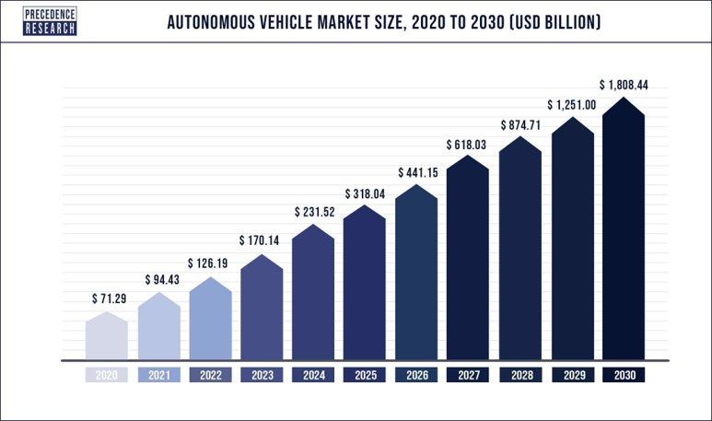

Autonomous vehicle market growth 2020-2030 (USD Billions)

# Functional and Non-Functional Requirements

## Functional requirements

* The system recognizes the user from the face autonomously.
* The system profiles the user and uses it to provide a personalized virtual guide experience.
* The system must provide basic commands to interact with the user.
* The system must extract and collect into the user profile information about user’s emotions from the face.
* The system must provide a rank of the car basing on the average score of their different simulations.

## Non-functional requirements

* Reliability: the application guarantees and accuracy of at least 90% on emotion recognition (high accuracy in recognize positive emotions).
* Accessibility: the application must always be accessible by all the users.
* Privacy: the application must guarantee the privacy of all the users.
* Performance: the application must guarantee a fast detection of the user mood and ability to detect changes of the mood.
* Capacity: high storage capacity, platform provides high resources.

# Platform Architecture

In the figure below is defined a possible architecture for our platform considering the modules that offer the different functionalities. Have also been highlighted the relations between the modules. The application can use the services provided by the platform in a transparent manner, without any knowledge of the implementation details. In particular, the following elements have been identified:

* **User profile module**: it stores all the profile information, including the simulations score of the users for each car.
* **Input module**: handles the input coming from the Audio system (for the VUI) and the Video system (for emotion recognition).
* **Car suggestion module**: it analyzes all the information regarding the mood detected during the simulations stored in the user profile and suggests a car.
* **Virtual road module**: it provides the simulation based on the information available in the user profile; core of the platform, this system analyzes the landmarks of the face and extrapolates the mood of the person.
* **User interaction module**: this system handles the interaction between the user and the car.

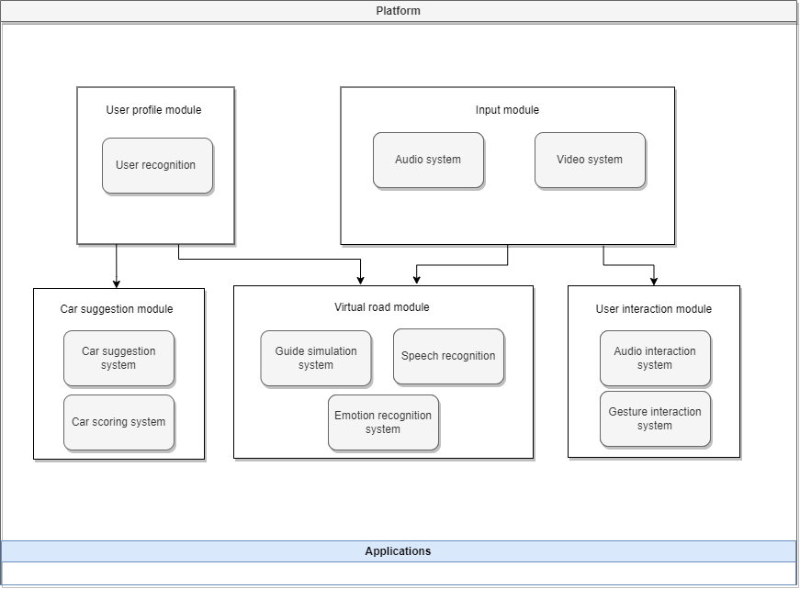

High-level view of the project architecture

The application in the layer below, can be deployed over this platform without any knowledge of the implementation details.

Whenever a user enters the car, all the user profile information’s is retrieved from the cloud and, meanwhile, some information is acquired by the platform thanks to the input system.

The different sensors collect information for the emotion recognition module. This module helps the platform to identify the emotion of the user during the simulation. This information is used to update the user profile and suggest the best car.

The information regarding the user profile, including also the emotion score for each simulation and guide experience, is stored in a remote server hosted in a cloud.

Different cloud services have been compared to find the one that suits the best the application needs. First, the main cloud services have been identified. As it is possible to see in the following figure, the three main cloud services are AWS, Microsoft Azure and Google Cloud Platform [6][7]. AWS and Azure together cover 50% of the market.

Cloud market share (Q1 2022)

One of the main differences between these three cloud services is the availability zone.

* AWS covers 66 zones.
* Microsoft Azure covers 24 regions of the world in 140 countries.
* GCP is available in 24 regions with 73 zones.

The one with the higher coverage is AWS, followed by Azure. GCP was born a few years ago and doesn’t already have the coverage offered by the other two.

Another important aspect is the price:

* For a small instance of Amazon Web Services, it is necessary to pay around $69 USD per month. The price of a large instance however increases to about $3.97 USD per hour.
* A small Azure instance costs almost the same price as the AWS option, arriving at a $70 USD per month fee. However, the largest instance of Azure costs almost double, $6.79 USD an hour.
* Google Cloud only provides a basic $52 USD per month instance. A large GCP instance costs $5.32 an hour, standing right in the middle.

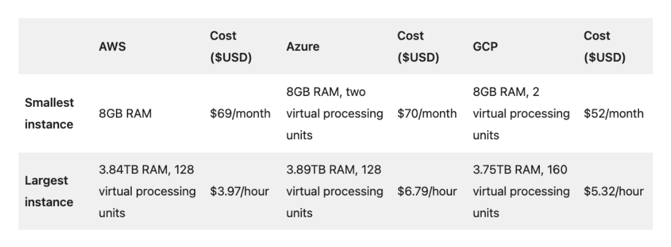 Cloud providers option costs

The price of AWS and Azure is almost the same. GCP is the cheapest but offers the lowest number of services. All three cloud services offer different storage solutions and different databases, both relational and non-relational databases.

Moreover, the advantage of Microsoft Azure is the strong compatibility with all the Microsoft products and the high number of tools and APIs that are useful in building an application.

GCP, on the other hand, has been focusing for years on AI and ML and offers a high number of advanced models.

AWS, moreover, offers a high number of services and it is the more stable of the three.

Based on the requirements of the project, the most suitable is Microsoft Azure. In fact, it provides services essential to the project and has good coverage with respect to the price.

# Working Staff

We have individuated the following profiles that will be involved in the development of the whole project based on their skills.

* **Front-End Developer:** the main characteristic of this expert is the knowledge of the graphic libraries that will be used to realize the graphic user interface of our application and the knowledge of the management of the signal that will be used in our application to update such an interface.
* **Back-End Developer:** this expert is responsible for the development of all the software needed to the implementation of the virtual environment. He is also in charge of providing the APIs to the higher levels and to the external applications that will exploit the platform for their services.
* **Embedded System Engineer:** the figure in this case is a proficient developer with the ability to design appropriate embedded system solutions with a high experience on the communication with signals from hardware components (possibly related to the automotive environment), the acquisition of real time data. These figures will be responsible also for the testing of the algorithm implemented.
* **Natural Language Processing Expert:** this figure oversees identifying which are the most used and advanced NLP cloud systems available on the market, also considering their costs and the system’s requirements. The expert must have a deep knowledge of the cloud APIs market and should be as neutral as possible to get the objective best solution without preponderance towards a system.
* **Machine Learning Engineer:** this expert is a person in IT who focuses on researching, building, and designing self-running artificial intelligence (AI) systems to automate predictive models. In particular, he must have a deep knowledge of all the ML pipeline related to the definition of the best possible classifier to perform the detection of the mood by exploiting all the data coming in input.
* **Data Analyst:** this figure oversees all the aspects related to the analysis of the data by paying particular attention in the data preparation, collection, and aggregation phase to define an ad-hoc dataset for the development of the ML model. He must have a strong knowledge of the data coming as output from the main modules of the platform to define a matching strategy as good as possible for the virtual room system.
* **Project Manager:** he oversees the project from initiation to close, making sure the work gets done efficiently and satisfactorily. He must have high experience in the automotive sector and strong capability to coordinate a team.
* **Marketing Manager:** this expert must have strong competence in defining the right marketing campaign and the budget for the project. He must also negotiate with external companies in the cloud and cybersecurity sector to get the best solution.

# Work Packages



Work packages and tasks

## Summary Table

|  |  |  |
| --- | --- | --- |
| WP | Description | Tasks |
| Coordination & Management |  | 1. Project coordination. |
| Feasibility Analysis | In this first package the market research analysis of the competitors is carried out, the functional and non-functional requirements of our product are analyzed to define the structure of the platform. | 1. Objective & Goals Definition. 2. Platform Specification. 3. Functional Requirements. 4. Non-Functional Requirements. |
| GUI/VUI Module | Creation of a modern, user friendly, easy to use interface that makes the experience inside the car better. | 1. HM Interaction Guidelines. 2. Software Development. 3. GUI Test. 4. VUI Test. |
| Mood Recognition | In this WP we study the different mood recognition services already available on the market and evaluate the best options to integrate with our product. | 1. SotA Analysis. 2. Data Collection & Preparation. 3. Training, Validation & Testing 4. Product Suggestion. |
| Virtual Road | In this WP all the tasks related to the implementation of the virtual room service are grouped. | 1. Profiling Strategy Definition. 2. Framework Integration. 3. Simulation Environment Implementation. 4. Simulated Road Test. |
| Test & Deployment | Final WP in which all the tasks dedicated to the assessment of our product and its distribution are carried out. | 1. Testing Plan Definition. 2. Platform Specs & Requirements Check. 3. Deployment. 4. Monitoring. |

## Work Packages Description

### WP 1

|  |
| --- |
| **Title***: Project coordination and Management* |
| ***Weeks****: T0 + 36* |
| **Objectives***: Project coordination* |
| **General description of the WP:** *This step is related to all those activities that regard the coordination of different professionals to produce a step-by-step solution. Monitoring all the different phases of the project is the main aim of this task that must detect possible mistakes and solve them. Help to get out the documentation.* |
| **Activity***: Project coordination* |
| **Deliverables***: Monitoring, documentation* |
| **Personnel***: Project Manager, Market Manager, Embedded System Engineer* |

### WP 2

|  |
| --- |
| **Title***: Feasibility Analysis* |
| ***Weeks****: T0 + 14* |
| **Objectives***: Competitor Marketing Analysis, Platform specification* |
| **General description of the WP***: in this first package the market research analysis of the competitors is carried out, the functional and non-functional requirements of our product are analyzed to define the structure of the platform.* |
| **Activity***: Objectives & Goals Definition, Platform Specifications, Functional Requirements, Non-Functional Requirements* |
| **Deliverables***: Project documentation, SWOT Analysis, Perceptual Map* |
| **Personnel***: Project Manager, Marketing Manager, Embedded System Engineer* |

|  |  |  |  |
| --- | --- | --- | --- |
| Name | Description | Personnel | Weeks |
| Objectives & Goals Definition | The aim of this task is to study the field to which we are interested in. It is essential to define the challenges to cope with, to study the market by identifying competitors and customers, the objectives to be achieved with the project and the strategies that will be adopted to accomplish to them. | Project Manager, Marketing Manager | 4 |
| Platform Specifications | In this step all the functionalities and features of the platform are defined with all the modules required for the implementation. All the factors that could be involved are identified and categorized to better segment the market and provide a more specific product for different classes of users (use case). | Embedded system Engineer | 3 |
| Functional Requirements | Requirements analysis is a very critical process that enables the success of our system to be assessed. The functional requirements are defined through the use cases and represent all these functionalities need to be necessarily incorporated into the system as a part of a contract. | Embedded system Engineer | 5 |
| Non-Functional Requirements | Subsequently the non-functional requirements are described to identify the quality constraints that the system must satisfy according to the project contract. | Embedded system Engineer | 5 |

### WP 3

|  |
| --- |
| **Title***: UI Module* |
| ***Weeks****: T8 + 18* |
| **Objectives***: Definition and Implementation of HM interface with subsequent testing* |
| **General description of the WP***: Creation of a modern, user friendly, easy to use interface that makes the experience inside the car better.* |
| **Activity***: HM Interaction Guidelines, Software Development, GUI Test, VUI Test* |
| **Deliverables***: GUI guidelines and user interface prototype* |
| **Personnel***: Front-end Developer, Back-end Developer, NLP Engineer* |

|  |  |  |  |
| --- | --- | --- | --- |
| Name | Description | Personnel | Weeks |
| HM Interaction Guidelines | Doing extensive research to discover user needs, carrying out numerous iterations, and gathering feedback to achieve adequate performance of the product and its design. it is essential to define a series of guidelines that provide readability, usability, and safety. | Front-end developer, NLP Engineer | 4 |
| Software Development | The user interface must be designed as an easy-to-use one, possibly textless and graphically attractive. These are key points for a successful product since users want their usage experience to be as satisfying as possible. We have then to design a two-way user interface, one graphic and one vocal, to increase the flexibility with which users can interact with the system to insert new tasks or to monitor the progress in the execution of the previously inserted tasks. | Front-end developer, Back-end developer, NLP Engineer | 6 |
| GUI Test | Check Graphic User Interface, it must be simple and intuitive to simplify the usage of the platform. In this part also the proper functioning of the GUI is checked  through the use cases and represent all these functionalities need to be necessarily incorporated into the system as a part of a contract. | Front-end developer | 4 |
| VUI Test | Check Voice User Interface, it must be simple and easy to use to encounter the needs of the users. In this part also the correct recognition of the command given by user is checked. | NLP Engineer | 4 |

### WP 3

|  |
| --- |
| **Title***: Mood Recognition* |
| ***Weeks****: T8 + 21* |
| **Objectives***: Searching for the best network for mood recognition* |
| **General description of the WP:** T*his package contains all the steps necessary for the creation and choice of the best neural network dedicated to mood recognition* |
| **Activity***: SotA Analysis, Data Collection & Preparation, Training, Validation & Testing, Product Suggestion* |
| **Deliverables***: Best network for mood recognition* |
| **Personnel***: Data Analyst, ML Engineer, NLP Expert* |

|  |  |  |  |
| --- | --- | --- | --- |
| Name | Description | Personnel | Weeks |
| SotA Analysis | Initial phase in which the most recent discoveries from a technological point of view are analyzed regarding the recognition of the mood from expressions, gestures, tone of voice, heart rate. We go in search of possible approaches to be taken into consideration published in the scientific world. | ML Engineer, NLP Engineer | 4 |
| Data Collection & Preparation | In this phase data are collected from different sources which can also be different. This data is aggregated and normalized. At this point the collected data is analyzed, the respective classes are assigned and to make a more in-depth study: the classes must be balanced (oversampling or under-sampling techniques), and the study of input coverage is also essential. Once the pre-processing is finished, the data is ready to be transformed to extract the features. At this point it is essential to divide the data into three different sets by choosing the splitting percentages. | Data Analyst | 6 |
| Training, Validation & Testing | Several neural networks are examined which are trained by setting the hyperparameters.  Once the training is completed the validation phase is carried out in which the best hyperparameters for the networks under examination are chosen, but before going on, it is necessary to check that the networks are not overtrained.  In the last phase the best network is tested on the test set. Also, in this case it is necessary to make sure that the error on the test set and training set is not beyond a certain threshold, otherwise it is necessary to collect new samples. | ML Engineer | 7 |
| Product Suggestion | Phase were the data collected by the various sensors to exert mood recognition are used to compute the various car suggestions to generate a detailed ranking and help the user in its choice. The vary rules on how to create this ranking are defined in this stage. | ML Engineer, Data Analyst | 4 |

### WP 4

|  |
| --- |
| **Title***: Virtual Road* |
| ***Weeks****: T8 + 23* |
| **Objectives***: Virtual Road system concept and integration* |
| **General description of the WP***: in this WP all the tasks related to the implementation of the virtual road service are grouped* |
| **Activity***: Profiling Strategy Definition, Framework Integration, Simulation Environment Implementation, Simulated Road Test* |
| **Deliverables***: Virtual Road System* |
| **Personnel***: Data Analyst, Embedded System Engineer, Front-End Developer, Back-End Developer* |

|  |  |  |  |
| --- | --- | --- | --- |
| Name | Description | Personnel | Weeks |
| Profiling Strategy Definition | The aim of this task is to provide clear ways of matching strategy. This means that we focus the attention on the possible interests that a user may have and how these interests can be matched. We define macro-topics, that express more general information and collect more specific sub-topics. | Data Analyst | 4 |
| Framework Integration | Integration of the main modules of the platform and how they must communicate among them. | Embedded System Engineer | 5 |
| Simulation Environment Implementation | The platform must provide an easy solution to be exploited by third party companies. A set of functions (API) will be exposed to allow application to use SPI functionalities. A virtual experience must be implemented by combining all the sensors and devices provided but that can be also modulable and applied to systems with different configurations. | Front-End Developer, Back-End Developer | 8 |
| Simulated Road Test | Phase where all the implemented virtual experiences are tested by combining the feedback of the various sensors and multimedia devices (primarily the displays) to detect delays and desynchronizations guaranteeing a simulation as defined as possible. | Embedded System Engineer | 6 |

### WP 5

|  |
| --- |
| **Title***: Test & Deployment* |
| ***Weeks****: T13 + 20* |
| **Objectives***: Service deployment and testing* |
| **General description of the WP***: Final WP in which all the task dedicated to the assessment of our product and its distribution are carried out* |
| **Activity***: Testing Plan Definition, Platform Specs & Requirements Check, Deployment, Monitoring* |
| **Deliverables***: Platform infrastructure development* |
| **Personnel***: Embedded System Engineer, Data Analyst* |

|  |  |  |  |
| --- | --- | --- | --- |
| Name | Description | Personnel | Weeks |
| Testing Plan Definition | Some standard tests to measure the requirements are defined. Once each requirement is passed through these tests they are evaluated and freeze. Analysis of the results of the project from a business perspective, and identification of business cases for the exploitation of the results. | Embedded System Engineer | 4 |
| Platform Specs & Requirements Check | The main objective of this work package is to ensure the achievement of the project objectives and meet the contractual commitments through administrative coordination as well as providing the measures that will help to achieve the expected project impacts. | Embedded System Engineer | 6 |
| Deployment | The result will be a fully working system that can be deployed and sold. The system will be able to recognize the mood and understand the topic from a conversation (associate to each user) to discover the best matches. integration and deployment of the technologies and infrastructure required to set up. | Embedded System Engineer | 6 |
| Monitoring | A performance monitoring system is defined and assembled within the project to keep the accuracy and reliability of our product under control. | Embedded System Engineer, Data Analyst | 4 |

# GANTT

In the picture below we designed the GANTT chart for the development of our platform.



# Risk analysis

An autonomous vehicle involves multiple subjects, including computing systems, machine learning, communication, robotics, mechanical engineering, and systems engineering, to integrate different technologies and innovations.

Now we must identify the main business risks for our project. We listed all the critical components of our project that expose some risks, namely all the aspects that may lead to a project failure or reduction of profits. After a deep analysis of our project and all its components, we have identified the main possible risks that could cause economic damage to the company.

## Cloud Risks

For each cloud component in our system (NLP, Simulation Selection, Emotion Recognition) after having chosen one implementation for each of them, we may find a better one in the market, both in terms of performance and cost. Moreover, after having implemented the system with a specific cloud service in mind, the selling company may change its license agreement.

For these reasons, it is very important to focus on a deep market analysis to choose the best cloud service, taking in consideration its possible evolution in the future, both in terms of technical support, software updates (usually not a problem when considering cloud solutions) and stipulated license agreements.

Hardware Risks  
  
The target hardware may become obsolete in a short time, since hardware’s evolution rate is quite high. We can overcome this problem by developing our application while limiting the part of hardware dependent code (e.g., writing the code in a high-level programming language, running the code on a general-purpose OS).

As example we can face a microcontroller obsolescence, meaning that could be found on the market better HW systems at lower prices.

A possible solution we propose to face that risk is implementing our application using non-hardware programming languages or at least reducing to 5/10% the quantity of code HW dependent.

Software Risks  
  
For each component in our system, after having chosen one implementation for each of them, we may find a better one in the market, both in terms of performance and cost. Moreover, after having implemented the system and stipulated contracts with partners they may change its license agreement.

For these reasons, it is very important to focus on a deep market analysis in order to choose the best SDK service, taking in consideration its possible evolution in the future, both in terms of technical support, software updates and stipulated license agreements.

A possible solution could be to choose the most integrable and composable SDK to make and eventual porting as easy and modulable as possible.

Artificial Intelligence Risks  
  
The last component that could be the subject of business risks is related to the Neural Network. Like the previous case, the risk is Neural Network obsolescence, meaning that more accurate and reliable models could be found on the market.

The solution we propose is abstracting the class implementation methods to be called independently from the below Neural Network. In this way if we find a new and more accurate system, we may replace it without any change in the application code.

Another aspect to consider is the concept drifting because data may change over time. When concept drift occurs, the model used can make more and more mistakes in detecting the mood, if not updated. We can define some thresholds to detect errors (on misclassified instances) and to decide the right time to retrain the model.

## Privacy Risks

As the vehicle captures a massive amount of sensor data from the environment, vehicle data privacy becomes a big issue. For example, all the aspects related to the profile of the users and all its experiences need to be treated very carefully. Furthermore, who owns this data is also an important issue, which requires the system’s support for data access, storage, and communication.

A possible solution is to rely on expert cybersecurity companies for the management of data and to keep them safe.

|  |  |  |
| --- | --- | --- |
| Risk | Problem | Solution |
| Cloud | License agreements, performance, costs. | Deep market analysis to identify the best technical support, SW updates and license agreements. |
| Hardware | Better HW system at lower price. | Exploit programming languages not HW related. |
| Software | Better SW system at lower price. | Exploit highly compatible and modulable SDK. |
| Artificial Intelligence | More accurate models available. | Abstract the implementation of the class methods to make the model independent from them. |
| Privacy | Management of personal data. | Rely on external cybersecurity companies. |

# References

[1] <https://www.sae.org/blog/sae-j3016-update>

[2] <https://wellkeptwallet.com/car-buying-apps/>

[3] <https://www.statista.com/forecasts/997119/purchase-criteria-for-cars-in-the-us>

[4] <https://www.ice.it/en/index.php/invest/sectors/automotive>

[5] <https://www.statista.com/topics/975/motor-vehicle-production/#topicOverview>

[6] <https://sam-solutions.us/aws-vs-azure-v-s-google-cloud-which-is-better/>

[7] https://www.projectpro.io/article/aws-vs-azure-who-is-the-big-winner-in-the-cloud-war/401